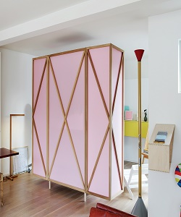

Wall Divider

$120.91

Availability: In stock

**Description:**

Beautiful and 'The brilliant pink color' for its vivid presentation in which the landscape is in perspective, pavilions and towers are exactly the same as their real counterparts, figures show facial expression and birds and flowers are lifelike. this room divider can be used to define space in an open concept room, or can be set in front of a large window for privacy. Rounding out the design, metal hinges make folding and storage a breeze when not in use.